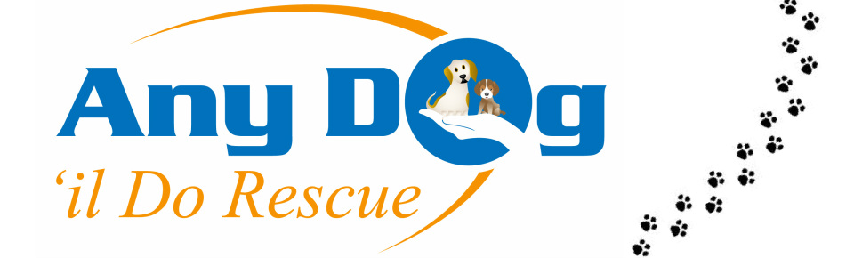
Scottish Registered Charity SC044302

Fundraising assistant volunteer
Flexible, ideally 8+ hours per month, home & community based

Who are we?
We are a dog rescue specialising in dogs who have been saved from being put to sleep in the pound. We also take some dogs who have been surrendered by their owners. We have a small number of kennels which we use for assessment and behavioural rehabilitation. Most of our dogs need time in a foster home to get used to a home environment, before they can find their forever home. We are not breed specific and support dogs of all sizes and breeds.
We are a charity who rely entirely on donations from adoptions and fundraising events.
Why volunteer with us?
We are completely volunteer managed. You’ll be joining a friendly team of volunteers who are all passionate about finding forever homes for our dogs and promoting good dog welfare.
Every dog we rehome saves two lives- not just one! Every dog who finds a forever home will save another life by creating a space in the kennels.

We are entirely funded by donations and our rehoming fees. A small amount really can make a difference to us, and you will see where your hard work goes!
We have a small, dynamic fundraising team who do bits of everything. There’s scope to focus on events, awareness raising, gift-in-kind, corporate supporters etc, or to do some of everything.

What will you be doing? The role is varied and can be tailored to your interests, but includes:
- Supporting our fundraising coordinators to run events
- Visiting corporate donors to gain support
- Sourcing gift-in-kind donations for raffle prizes etc
- Sending out sponsor packs to supporters
- Researching new areas of work or potential supporters
- Speaking about ADDR for groups (Corporates, rotary clubs, schools, Women’s groups etc)

What are we looking for in a volunteer?
- Friendly and enthusiastic
- A dog/animal lover
- Able to work under own initiative
- Organised
- Creative
- Good written and verbal communication skills

We ask that all of our volunteers….
Have a passion for helping dogs, believe that all dogs deserve a forever home.
Are friendly and respectful to our community (supporters, volunteers and followers on social media).

